Dear editors,

The authors would like to thank the editors and the reviewers for their valuable and constructive comments and suggestions. We hope that we have correctly interpreted their concerns in our responses and corresponding modifications in our manuscript. We hope that this revision meets the high standards of IEEE Transactions on Emerging Topics in Computational Intelligence. We are truly interested in publishing our new results in your prestigious journal. Your consideration will be deeply appreciated.
Sincerely,
Authors

*************** Reviews ***************
Referee: 1
Comments to the Author
This manuscript mainly develops a novel broad neural network named collaborative-competitive representation-based graph regularization broad learning system (CC-GBLS), which incorporates a collaborative-competition mechanism to the graph regularization broad learning system (GBLS). The proposed CC-GBLS model not only considers the intrinsic relationships of input data during the training process, but also obtains better feature representation through collaborative-competitive representation-based autoencoder. Then a CC-GBLS based approach is proposed for osteoporosis diagnosis. Though the research topic is fascinating, however, there are still some defects in the manuscript as follows.
1. Please explain why the LumberX-ray dataset is firstly segmented before image enhancement, what is the benefit of segmentation?

Author response: Thanks for your valuable comments. According to the comments, we already added the explaination why the LumberX-ray dataset is firstly segmented before image enhancement and the benefit of segmentation in the Section III.

The related contents in the manuscript are listed as follows:
“As we known, high-quality image data is benefit for training a model with better performance. The quality of data pre-processing is crucial for the subsequent data processing. Here, the lumbar regions L1-L4 shown in Fig. 2 as regions of interest (ROI) of Lumber X-ray images are adopted for training the model. In order to avoid the effects of noise and other redundant information in the Lumber X-ray images, ROI of Lumber X-ray images are necessary to be firstly individually extracted. Thus, in order to obtain the high-quality ROI, we need to segment the Lumber X-ray images by a minimum indented rectangle method before enhancing the images. By analyzing the texture information within these ROI and extracting key features of ROI, we can further improve the classification performance of our traning model.”

2. The expression of the analysis part of the experimental results in section 5 is not clear, could you add more discussion about the analysis? It should be more concise and precise.
Author response: Thanks for your valuable comments. We already repolish the expression of the analysis part of experimental results in Section IV and marked all the repolished contents in blue color. Besides, we also added a disscussion part titled “5) Ablation study of CCRAE mechenism, graph regularization and GLCM+LBP extraction modules” in Part B, Section IV. And the results analysis should be clear, more concise and precise.

The related contents in the manuscript are listed as follows:

- polished part:

Orignal content:
For the LumberX-ray dataset, as shown in TABLE V, the ACC, Specificity, Sensitivity, and other metrics are calculated for each kind of feature. When using CC-GBLS and BLS as our classifiers, the feature extraction methods(LBP+GLCM) used in this paper both achieve the highest ACC, 79.78% and 76.97%, respectively. What’s more, when using CC-GBLS as the classifier, the proposed model is higher than other models in all metrics. When using BLS as the classifier, the model with hybrid features also achieves higher results than other models in Sensitivity, NPV and PPV
Polished content:
As shown in TABLE V, six metrics are calculated for each kind of feature for the LumberX-ray dataset. When using CC-GBLS as our classifier, the proposed feature extraction method(LBP+GLCM) outperform other models in all metrics. What’s more, when using BLS as the classifier, LBP+GLCM also achieves the highest ACC(76.97%), Sensitivity(78.65%), NPV(77.97%) and PPV(82.32%).

Original content:
For the KXO dataset, when using CC-GBLS and BLS as our classifiers, the feature extraction method(LBP+GLCM) used in this paper both achieve the highest ACC, 93.51% and 86.49%, respectively. Besides, as shown in TABLE VI, when using CC-GBLS as the classifier, the proposed method outperforms other models on AUC. Three models perform similarly on Sensitivity, Specificity, NPV and PPV. When using BLS as the classifier, the proposed method achieves the best performance on ACC, Sensitivity and NPV. The GLCM method performs best on AUC, Specificity and PPV.
Polished content:
TABLE VI shows the results on the KXO dataset. When using CC-GBLS as the classifier, LBP+GLCM performs best in ACC(93.51%) and AUC(95.29%). Three models obtain similar results in Sensitivity, Specificity, NPV and PPV. When using BLS as the classifier, the proposed mothod achieves the best performance on ACC(86.49%), Sensitivity(98.41%) and NPV(99.13%). Besides, the GLCM method performs best in AUC(92.97%), Specificity(100%) and PPV(96.43%).

- Ablation study of CCRAE mechenism, graph regularization and GLCM+LBP extraction modules
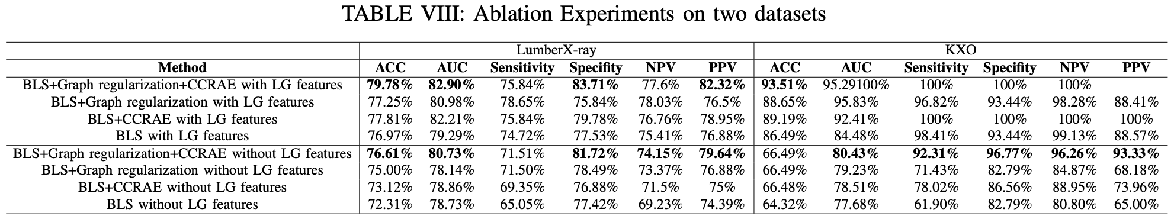
We conducted ablation experiments on the LumberX-ray and KXO datasets to evaluate the effectiveness of each module. TABLE VIII contains the results of these experiments. When we remove the LBP+GLCM feature extraction(LGFE) module, the CCRAE module and graph regularization module both enhance the performance of BLS on two datasets. On the LumberX-ray dataset, incorporating the CCRAE module improves the performance of BLS in ACC, Sensitivity, Specificity, NPV, PPV. Incorporating the graph regularization module improves BLS in ACC, AUC, Sensitivity, NPV and PPV. On the KXO dataset, the two modules both improve the performance of BLS in all metrics. Through incorporating the CCRAE mechanism module and graph regularization module simultaneously into BLS, we proposed the CC-GBLS model. As shown in TABLE VIII, the proposed model achieves 1.61% improvement in ACC, 2.59% improvement in AUC, 3.23% improvement in Specificity, 0.78% improvement in NPV and 2.76% improvement in PPV on the LumberX-ray dataset. On the KXO dataset, the proposed model achieves the highest AUC, Sensitivity, Specificity, NPV and PPV. By adding the LGFE module, there is a significant improvenment in model performance. The proposed CC-GBLS model achieves 27.02% improvement in ACC, 14.77% improvement in AUC, 7.49% improvement in Sensitivity, 3.33% improvement in Specificity, 3.74% improvement in NPV and 6.67% improvement in PPV on the KXO dataset. On the LumberX-ray dataset, the proposed model also achieves 3.17% improvement in ACC, 2.17% improvement in AUC, 4.33% improvement in Sensitivity, 1.99% improvement in Specificity, 3.45% improvement in NPV and 2.68% improvement in PPV. With the LGFE module, incorporating the CCRAE module improves the performance of BLS in ACC, AUC, Sensitivity and NPV on the LumberX-ray dataset. And it also achieves 2.16% improvement in ACC, 11.35% improvement in AUC on the KXO dataset. Incorporating the graph regularization module improves the performance of BLS in all metrics on two datasets. What’s more, the proposed model that integrates the CCRAE module and graph regularization module simultaneously into BLS achieves 1.97% improvement in ACC, 0.59% improvement in AUC, 3.97% improvement in Specificity, and 3.37% improvement on the LumberX-ray dataset. On the KXO dataset, the proposed model achieves the best performance in ACC, Sensitivity, Specificity, NPV and PPV.
3. The numbers and the description in the confusion matrix plotted in Fig. 7 are not clear enough, please describe them in detail.
Author response: Thanks for your valuable comments. We have redrawn the confusion matrix and added subheadings to each subgraph in Fig. 4 to make them clearer. Besides, we add more analysis in the part titled “1) Performance Comparison Between The Proposed Model and Other Models” in Part B, Section IV to describe the confusion matrixes in detail.

The related contents and figures in this manuscript are listed as follows:

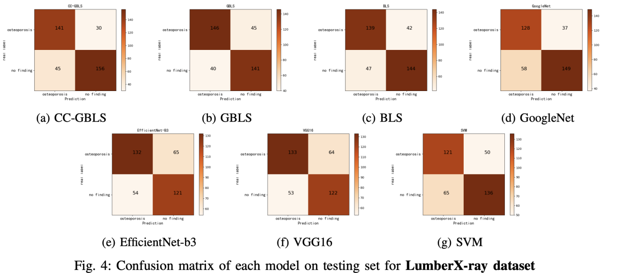

“The confusion matrix of each model on the testing set is calculated and the results are shown in Fig. 4. The confusion matrix is a square matrix with rows and columns representing the actual and predicted classes, respectively. The diagonal elements of the matrix represent the number of correctly classified instances, while the off-diagonal elements represent the misclassifications. Fig. 4 demonstrates that CC-GBLS achieves the best performance, with 141 positive samples and 156 negative samples correctly classified.”
4. There are some format errors, check the title of all images using Fig. XX
Author response: Thanks for your valuable comments. According to the comments, we have repolished the whole manuscript and correct the format errors. After careful examination, we have checked the title format of all the images and changed the incorret title to Fig. xx.

The related contents in this manuscript are listed as follows:
“...As shown in Fig. 1, BLS with a flattened network structure is quite different from deep learning models...”
“...Moreover, the confusion matrix of each model on the test set is also calculated and the results are shown in Fig. 4...”

Referee: 2
Comments to the Author
A broad neural network is utilized for automatic diagnosis of osteoporosis in this manuscript. A graph is constructed to represent intrinsic relationships between original osteoporosis data. Experiments are conducted.
Comments or Questions:
1. In Section 1, the relationship between the summarized research works and the research issue in this manuscript is not clear enough.
Author response: Thanks for your valuable comments. Most existing research works for the automatic diagnosis of osteoporosis are based on CNN models. However, there are still limitations to using these complex CNN models to achieve better performance. Broad learning system(BLS), as a flattened network, can dramatically reduce computing time and resources while ensuring comparable performance with deep neural networks. However, there are still limitations and challenges when appying BLS to the automatic diagnosis of osteoporosis. To address these issues, we propose a novel broad neural network named CC-GBLS that integrates CCRAE mechanism into graph regularized broad learning system(GBLS). And it achieves better performance in automatically diagnosing osteoporosis. We already revised the corresponding part of Section I to demonstrate the relationship between the summarized research works and the research issue in this manuscript.
The related contents in this manuscript are listed as follows:
“Although deep learning has demonstrated its effectiveness, the complex deep structure and numerous parameters in deep neural network necessitate a large amount of training data, computer resources and training time. Besides, deep learning based model is also frequently overfitted because of insufficient sample data. To solve the above issues, broad learning system(BLS) is proposed as an alternative method of deep structure. BLS can utilize feature nodes and enhancement nodes to extract features from data, and the output coefficients of BLS can connect each node with the objective matrix[10]. Compared with deep learning, BLS with flat structure
greatly reduces the computing time and resources used while ensuring comparable performance with deep neural networks. Multiple BLS based models were proposed such as Multiview BLS(MvBLS) [11], Sparse Enhancement Fuzzy BLS [12], Fuzzy BLS [13], Convolutional BLS [14], Discriminative group-sparsity constrained BLS [15], BroadSurv [16] which have made significant progress in varied fields. Taking into account the local invariance of the data, discriminative graph regularized broad learning system (GBLS) was proposed [17], which incorporates manifold learning into traditional BLS. Although much effort has been dedicated to BLS approach, there are still challenges and limitations when applying broad neural networks to the automatic diagnosis of osteoporosis:
- The distinction between the X-ray images of patients and those of healthy people is not clear. This means there are many noise and redundant information in the images can affect the classfication accuracy of BLS. In order to identify osteoporosis people from no findings accurately, the learning ability of standard BLS should be improved to obtain more useful information.
2) Standard BLS utilizes the random mapping and sparse autoencoder mechanism to map the input data. However, the distribution of osteoporosis data is complex, which limits the data representation performance of standard BLS. Thus a new feature mapping method with powerful feature representation capability is needed;
These days, regularization techniques and manifold learning have been widely applied to the automatic diagnosis of osteoporosis and bone measurement to enhance the learning ability of models. The least absolute shrinkage and selection operator regularization (LASSO) model [18] was applied to generate a risk assessment tool for identifying osteoporosis, which is clinically proven to work. Combined with manifold regularization, including local structurepreserved manifold regularization (LSPMR) and adaptive local shape-constrained manifold regularization (ALSCMR), a novel cascade amplifier regression network (CARN) is proposed for automated quantitative measurement of the spine [19]. To present texture analysis characterization techniques for the effective diagnosis of osteoporosis, a novel regularization dimension method is proposed [20], which uses a series of local fractal dimensions instead of a single global fractal dimension to characterize local texture variations. Considering the local invariance of the data, Junwei Jin et al. proposed discriminative graph regularized broad learning system (GBLS) [17] that incorporates manifold learning into traditional BLS and achieves better performance. They utilized the graph regularization algorithm to make the proposed model learn the intrinsic relationship between input data. Motivated by the effectiveness of regularization and manifold learning, we proposed an automatic diagnosis method based on graph regularized broad learning system to improve the limited learning ability of traditional BLS. However, insufficient data representation and mapping capabilities also limit the performance of the model.
Due to the robust representation ability, Collaborative-competitive representation(CCR) has recently become a hot topic. CCR mechanism not only considers the collaborative reconstruction of the features but also adds the crucial discrimination among different samples for better feature representation. Many algorithms based on CCR mechanism have been proposed for classification tasks. Haoliang Yuan et al. [21] first proposed a collaborative-competitive representationbased classifier (CCRC) model incorporating a regularization constraint term into the objective function of CRC. CCRC considers the inter-class pattern discrimination among the classspecific representations. Zi-Qi Li et al. [22] proposed sparse and collaborative-competitive representation- based classification (SCCRC), which fuses sparse representation and collaborative-competitive representation for image classification. Jianping Gou et al. [23] propose weighted discriminative collaborative-competitive representation (WD-CCR) to achieve robust image classification, which designs the discriminative and competitive collaborative representation among all the classes by fully considering the class information. Inspired by the efficiency of the CCR algorithm, we designed a novel model named collaborative-competitive representationbased graph regularized broad learning system(CCGBLS) for automatic diagnosis of osteoporosis, which incorporates the collaborative-competitive representation mechanism into GBLS. The proposed model improved the feature representation capability and enhanced the learning ability of traditional broad neural networks.”
2. Existing methods related to automatic diagnosis of osteoporosis should be summarized and analyzed.
Author response: Thanks for your great suggestion on improving the accessibility of this manuscript. With the advancements in artificial intelligence, most existing methods related to the automatic diagnosis of osteoporosis are based on machine learning and deep learning algorithms. These methods have achieved significant progress. According to the comments, we add a discussion part titled “A. Existing automatic diagnosis methods” in Section II to summarize and analyze the existing methods of automatic diagnosis of osteoporosis.

The related contents in this manuscript are listed as follows:
A. Existing automatic diagnosis methods
“Recent advancements in machine learning have enabled artificial intelligence to make impressive breakthroughs in complex data environments where identifying high-dimensional relationships is difficult for humans. One such domain is osteoporosis. Various methods based on machine learning and deep learning algorithms have been proposed to diagnose osteoporosis automatically. Lee et al. [8]proposed a basic CNN model with three convolutional layers (CNN), visual geometry group deep CNN model (VGG16) on the classification of specific features of osteoporosis in Dental panoramic radiographs (DPRs). Besides, they utilized various transfer learning strategies and fine-tuning to achieve the best performance. Yamamoto et al. [7] considered using deep learning to diagnose osteoporosis from hip radiographs. In their evaluation of five CNN models, GoogleNet and EfficientNet b3 exhibited the best accuracy, precision, and specificity. Shim et al. [27] already developed machine-learning models to forecast osteoporosis risk. They have employed various techniques such as decision tree (DT), support vector machine (SVM), artificial neural networks (ANN), and logistic regression (LR). Tecle et al. [28] have created a series of CNN models that can accurately identify osteoporosis from non-osteoporosis. They utilized LeNet for classification and FSN-8 CNN for segmentation. Zhang et al. [29] have developed a deep convolutional neural network (DCNN) model composed of five-layer CNN to classify osteopenia and osteoporosis with the use of lumbar spine X-ray images. These deep learning-based automatic diagnosis methods achieved excellent performance, which demonstrates that deep-learning diagnostic networks may have the potential to screen osteoporosis and osteopenia.
However, training CNN models can be a time-consuming and resource-consuming task due to their complex structure and numerous parameters. Additionally, overfitting is a common problem for most CNN models. To address these issues, we propose an improved broad learning system with a flattened architecture and fewer parameters. Our proposed model can efficiently prevent overfitting during the training process and learn more knowledge.”

3. Is it difficult to automatically diagnosis of osteoporosis using broad neural networks? Where are the challenges? These should be clearly explained in the appropriate position of the manuscript.
Author response: Thanks for your valuable comments. Although broad neural networks are more easy-training and lighter than CNN models with flattened architecture, there are challenges and difficulties in applying broad neural networks to the automatic diagnosis of osteoporosis. The learning ability and feature representation capability of BLS needs to be improved. And how to extract appropriate bone image features for training BLS models is also a major challenge. We add some content in Section I to describe the challenges of applying broad neural networks to automatical diagnosis of osteoporosis. Besides, we reclaim the challenges and overview the contribution we have made to address these issues in the “Discussions” part, Section IV.

The related contents in Section I are listed as follows:
“Although much effort has been dedicated to BLS approach, the noted algorithms suffer from the following limitations and challenges when applied to osteoporosis automatic diagnosis:
1)The learning ability of traditional BLS in the field of bone CT image classification is not strong enough;
2) The feature representation capability of the sparse autoencoders used in these advanced models is still limited;
3) Extracting appropriate bone image features is critical for training broad neural networks.”

The related contents in “Discussions” part, Section IV are listed as follows:
“Broad neural network is a relatively easy-training network on medical image datasets, which significantly reduces computational complexity and avoids overfitting issues. However, there are still specific issues and challenges when it comes to using it for the automatic diagnosis of osteoporosis.
First, compared to images, BLS is more suitable for processing features extracted from images. In this manuscript, we utilized two different extraction methods, LBP-uniform and GLCM, and then concatenated them. Second, in some cases, the distinction between images of patients and those of healthy people is unclear, and the data distribution is also complex. As a result, it is difficult for BLS to fit the data through non-linear mapping successfully. In this manuscript, we utilized two methods to improve BLS. 1) We added the graph regularization term on the objective of standard BLS, making the learned output weights in the proposed model more discriminative. 2) On this basis, we incorporated the CCRAE algorithm to improve our model's feature representation ability. The data processed by the CCRAE algorithm has more compelling information, which can help the model training; Through these methods, we improved the learning ability of standard BLS on the automatic diagnosis of osteoporosis.”

- Analyze the complexity of algorithm 1.
Author response: Thanks for your valuable comments. According to the comments, we gave the complexity of algorithm1 as follows. The computational complexity of the algorithm can be represented by $T_{CCGBLS}$. Thus, we can obtain the complexity of algorithm 1 through formula 1:
$$T_{CCGBLS}=T_{1}{+T}_{2}{+T}_{3}{+T}_{4} (1)$$
Where $T_{1}$ represents the time complexity of the module that generates mapping nodes, $T_{2}$ represents the time complexity of the module that generates enhancement nodes, $T_{3}$ represents the time complexity of the module that obtains the graph regularization term $L_{G}$, and $T_{4}$ represents the time complexity of the module that obtains the connecting weight matrix W.
Suppose the input data $X {ϵR}^{N∗k_{0}}$, output results $Y {ϵR}^{N∗C}$, mapping nodes group is n, enhancement nodes group is m.
The module that generates mapping nodes can be divided into three phases. First, we utilize formula $Z_{random(i)}=XW_{random(i)}$ to obtain original random features $Z_{random(i)}$. So the time complexity of this phase is O($N$*$k_{0}$*$k_{1}$); Second, we can obtain the mapping matrix $W_{zi}$ through CCRAE mechanism. Precisely, we construct matrix M through formula 2. Then we can obtain the close form solution of $W_{zi}$ through formula: $W_{zi}$ = EX, where $E = (1 + λ_{2})(Z^{T} Z + λ_{2}I + λ_{2}M )$. Thus the time complexity of CCRAE mechanism is O($k_{1}^{3}$) +O($k_{1}^{2}∗N$)+O($k_{1}∗N$)+O($k_{1}∗k_{0}∗N$); Third, we can utilize $W_{zi}$ and input data X to generate mapping nodes through formula $Z_{i}$ = ε(X$\hat{W_{zi}^{T}}$+ $a_{zi}$). The complexity of this is O($N$*$k_{0}$*$k_{1}$). These three phases iterate n times to generate mapping nodes layer. So the time complexity of $T_{1}$ can be calculated as $T_{1}$ = O(${n∗k}_{1}^{3}$)+O($n∗N∗k_{0}{∗k}_{1}$)+O($n∗k_{1}^{2}∗N$)+O($n∗k_{1}∗N$).
$$M=\begin{matrix}Z_{1}Z_{1}^{T} & ... & 0 \\ ... & Z_{i}Z_{i}^{T} & ... \\ 0 & ... & Z_{k1}Z_{k1}^{T}\end{matrix} (2)$$

Enhancement nodes are generated through $H_{j}$ = ψ(Z$\hat{W_{hj}}$ + $β_{hj}$ ), j=1,2,...,m. So $T_{2}$ = O($N∗m∗n∗k_{1}∗k_{2}$).
The module that calculates the graph regularization term $L_{G}$ can be divided into two phases. First, we construct graph G through formula 3. The time complexity of this phase is O($N^{2}$); Second, we obtain $L_{G}$ through $L_{G}=\sum_{i,j}{V_{i,j}{||\hat{y_{i}}−\hat{y_{i}}||}^{2}=Tr({\hat{Y}}^{T}L_{G}\hat{Y})}$and the complexity is O($N^{2}∗C$)+O($N∗C^{2}$). Hence, $T_{3}$ = O($N^{2}$)+ O($N^{2}∗C$)+O($N∗C^{2}$).
After obtaining mapping nodes, enhancement nodes and graph regularization term $L_{G}$, we can calculate the connecting matrix $W={(χ_{1}I+χ_{2}B^{T}L_{G} B+B^{T}B)}^{−1}B^{T}Y$, where B=[$Z^{n}|H^{m}$]. The time complexity is O($k_{1}^{3}$)+O(${(k_{1}∗n+k_{2}∗m)}^{2}$*N)+O($(k_{1}∗n$+$k_{2}∗m)∗N∗C$).
$$V_{ij}=\left\{\begin{aligned}1/N_{t}, l(X_{i})=l(X_{j}) \\ 0 , l(X_{i})≠l(X_{j})\end{aligned} (3)\right.$$
To sum up,
$T_{CCGBLS}=T_{1}{+T}_{2}{+T}_{3}{+T}_{4}=$O($k_{1}^{3}$)+O(${(k_{1}∗n+k_{2}∗m)}^{2}$*N)+O($(k_{1}∗n$+$k_{2}∗m)∗N∗C)+O(N^{2})+$O($N^{2}∗C$)+O($N∗C^{2}$)+O($N∗m∗n∗k_{1}∗k_{2}$)+O(${n∗k}_{1}^{3}$)+O($n∗N∗k_{0}{∗k}_{1}$)+O($n∗k_{1}^{2}∗N$)+O($n∗k_{1}∗N$). After simplifying this formula, we can obtain the time complexity of algorithm 1 is O(${(k_{1}∗n+k_{2}∗m)}^{2}∗N)+O((k_{1}∗n+k_{2}∗m)∗N∗C)+$O($N^{2}∗C$)+O($N∗C^{2}$)+O($N∗m∗n∗k_{1}∗k_{2}$)+O(${n∗k}_{1}^{3}$)+O($n∗N∗k_{0}{∗k}_{1}$)+O($n∗k_{1}^{2}∗N$).
Compared to GBLS, we utilize CCRAE mechanism to generate mapping matrix instead of sparse autoencoder mechanism. And we calculate their time complexity respectively to demonstrate the efficiency of CCRAE. As mentioned above $T_{CCRAE}$ = O($k_{1}^{3}$) +O($k_{1}^{2}∗N$)+O($k_{1}∗N$)+O($k_{1}∗k_{0}∗N$). And sparse autoencoder mechanism uses the ADMM method to solve the mapping matrix W iteratively. Suppose the number of iterations is k. So the time complexity is $T_{SA}$ = O($k_{1}^{3}$) +O($k_{1}^{2}∗N$)+O($k_{1}∗k_{0}∗N$)+O($k∗{k_{1}}^{2}∗k_{0}$). The parameter k is usually set to a larger value in order to get an exact approximate solution. Thus in most cases, $T_{SA}$>$T_{CCRAE}$ and CCRAE can achieve better and faster data-mapping.

These analysis of the computational complexity of Algorithm 1 are also placed into the part titled “2)Computational Complexity” in Part C, Section III.

5. The number of experimental datasets is only 2, and it is recommended to use more experimental datasets.
Author response: Thanks for your valuable comments. After conducting extensive surveys to the best of our abilities, we select two effective datasets and carry out several experiments on them. Through experiments from multiple perspectives, our proposed model is proven to have advantages over CNN models and traditional broad neural networks. We add the introduction of two new datasets in part titled “A. Dataset and Experiment Setting” in Section IV. Moreover, we add more content to analyze the experimental results on these two datasets from part (1) to part (6) in Part “B. Results Analysis”, Section IV

The related contents in “A. Dataset and Experiment Setting” part in Section IV：
“Deep features of hip radiographs datasets(Deep Feature Osteoporosis dataset): This dataset consists of 898 subjects, including 519 subjects with osteoprosis and 379 subjects with no findings. This dataset is divided into the training set and testing set with the ratio of 6:4. The dataset link is as follows: https://data.mendeley.com/datasets/gmg3vvmvj4/1
Bone fracture of several joints dataset(Bone Fracture dataset): This dataset consists of 9463 images, dividing into training set with 8863 images and validation set with 600 images. More information of this dataset can be accessed thorugh https://www.kaggle.com/datasets/vuppalaadithyasairam/bone-fracture-detection-using-xrays.”

Parts of the results analysis on the two datasets in “B. Results Analysis”, Section IV are listed as follows:
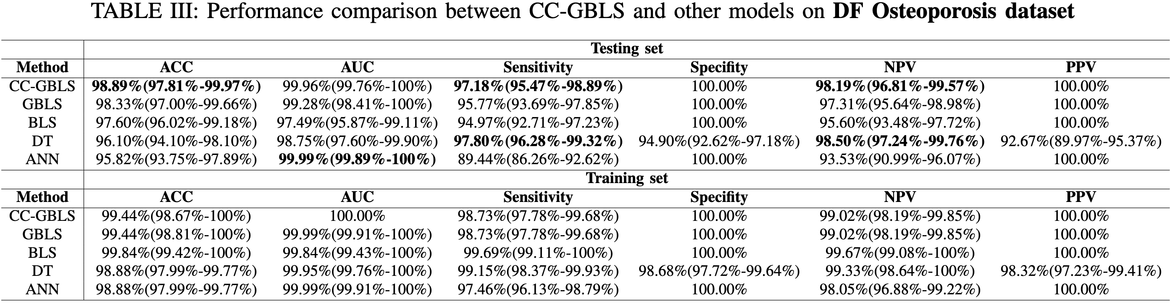
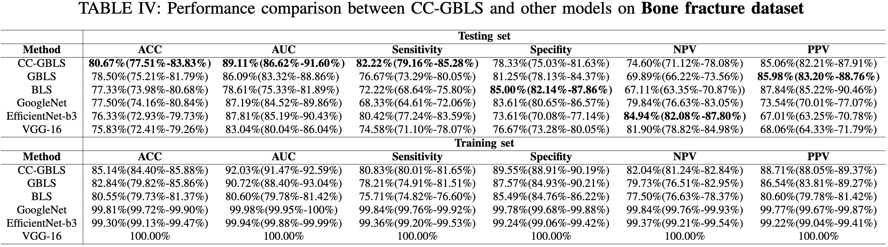
“For the Deep Feature Osteoporosis dataset, we compare it with GBLS, BLS and two traditional mechine learning models, Decision tree(DT) and Artificial neural network(ANN), which have been applied to automatic diagnosis of osteoporosis. The results are shown in Table III. CCGBLS achieves relatively better performance. It obtains the best accuracy(98.89%),
Specificity(100%), PPV(100%). ANN achieves the highest AUC(99.99%).
For the Bone Fracture dataset, we compare three broad neural networks with three classic CNN models. The results are shown in Table IV. CC-GBLS achieves the best accuracy(80.67%), AUC(89.11%), Sensitivity(88.22%).”

We already added the complete analysis of the experimental results on these two datasets and marked all added contents blue in the part “B. Results analysis”, Section IV.
6. What algorithms are baselines it this manuscript? Why? These should be explained clearly.
Author response: Thanks for your valuable comments. To address the issues when using existing algorithms for the automatic diagnosis of osteoporosis, we improve the traditional broad neural networks and develop a novel model named CC-GBLS. The proposed model outperforms several existing methods and traditional broad neural networks on four datasets. Hence, in this manuscript, there are two kinds of baselines in this manuscript. One kind refers to related models that have been applied to the automatic diagnosis of osteoporosis. Another kind refers to broad neural networks. We have added some content explaining the baselines in Section IV.

The related contents are listed as follows:
“Most automatic diagnosis methods of osteoporosis are based on deep learning algorithms. However, they are limited by the complex deep structure and massive parameters. In this manuscript, we first applied the broad neural networks to automatical diagnosis of osteoporosis. Hence, one kind of baselines refers to related models which have been applied to the automatic diagnosis of osteoporosis, such as Googlenet, Efficientnet, and SVM.
Moreover, we incorporated the CCRAE algorithm and graph regularization into BLS and proposed a novel model CC-GBLS to achieve better performance. Hence, another kind of baseline refers to broad neural networks which have been proposed, including GBLS and BLS. Through experiments, it has been verified that CC-GBLS outperforms GBLS and BLS.”

Referee: 3
Comments to the Author
The results look encouraging and motivating. But there are still some contents, which need be revised in order to meet the requirements of publish. A number of concerns listed as follows:
(1) In the introduction, the authors should clearly indicate the contributions and innovations of this paper.
Author response: Thanks for your valuable comments. According to the comments, we add some content describing the innovations of this paper in Section I, including incorporating the CCRAE mechanism into GBLS and designing an effective feature extraction method for osteoporosis images. Moreover, we revise the corresponding part in Section I to make our contributions clearer.

The related contents in this manuscript are listed as follows:
“The main innovations of this paper are listed as follows:
1) Inspired by regularization algorithm and manifold Learning's efficiency in bone measurement and osteoporosis detection, we applied GBLS, which owns a better learning ability for automatic osteoporosis diagnosis.
2) Inspired by the fantastic feature mapping ability of the CCR mechanism, we innovatively integrated the CCR mechanism into GBLS. Then we proposed a novel model named CCGBLS, which improves the data mapping capability of the mapping layer in standard BLS.
3) Inspired by the excellent information extraction ability of local features and texture features in medical images, we designed an effective feature extraction method for osteoporosis images, which combined the LBP-uniform algorithm and GLCM algorithm to achieve maximum representation of image information.”
The main contributions of this paper are listed as follows:
1) First applying broad neural networks for osteoporosis application: A novel Collaborative-competitive representation-based graph regularized broad learning system (CC-GBLS) based automatic diagnosis approach is first proposed for the automatic diagnosis of osteoporosis. To our knowledge, it is the first time to use a broad neural network for osteoporosis diagnosis application.
- Proposing a novel model named CC-GBLS: A novel broad neural network named CC-GBLS is first proposed in this paper, which integrates manifold learning with BLS and effectively obtains better feature representation based on the Collaborative-competitive mechanism. Additionally, embedding CCRAE into GBLS can also successfully improve the running speed of GBLS.
- Designing an effective extraction method: To achieve superior performance, we first utilize the Gray Level Co-Occurrence Matrix (GLCM) [24] and Local Binary Patterns (LBP) [25] algorithms to extract features from osteoporosis images, and then concatenate them to our proposed CC-GBLS model. Experimental results confirm the effectiveness of our proposed diagnostic approach.”

(2) Please highlight your contributions in introduction.
Author response: Thanks for your valuable comments. The contributions of our work can be categorized into three parts: Firstly, we utilized broad neural networks to diagnose osteoporosis automatically. Secondly, we proposed a novel model named CC-GBLS, which improves the classification capability of standard BLS. Lastly, we developed an effective extraction method that achieves superior performance. We have revised the relevant content in Section I to highlight these contributions.

The related contents in Section I are listed as follows:
“The main contributions of this paper are listed as follows:
1) First applying broad neural networks for osteoporosis application: A novel Collaborative-competitive representation-based graph regularized broad learning system (CC-GBLS) based automatic diagnosis approach is first proposed for the automatic diagnosis of osteoporosis. To our knowledge, it is the first time to use a broad neural network for osteoporosis diagnosis application.
- Proposing a novel model named CC-GBLS: A novel broad neural network named CC-GBLS is first proposed in this paper, which integrates manifold learning with BLS and effectively obtains better feature representation based on the Collaborative-competitive mechanism. Additionally, embedding CCRAE into GBLS can also successfully improve the running speed of GBLS.
- Designing an effective extraction method: To achieve superior performance, we first utilize the Gray Level Co-Occurrence Matrix (GLCM) [24] and Local Binary Patterns (LBP) [25] algorithms to extract features from osteoporosis images, and then concatenate them to our proposed CC-GBLS model. Experimental results confirm the effectiveness of our proposed diagnostic approach.”
(3) The computation complexity of the proposed method should be clearly described.
Author response: Thanks for your valuable comments. According to the comments, we gave the complexity of algorithm1 as follows. The computational complexity of the algorithm can be represented by $T_{CCGBLS}$. Thus, we can obtain the complexity of algorithm 1 through formula 1:
$$T_{CCGBLS}=T_{1}{+T}_{2}{+T}_{3}{+T}_{4} (1)$$
Where $T_{1}$ represents the time complexity of the module that generates mapping nodes, $T_{2}$ represents the time complexity of the module that generates enhancement nodes, $T_{3}$ represents the time complexity of the module that obtains the graph regularization term $L_{G}$, and $T_{4}$ represents the time complexity of the module that obtains the connecting weight matrix W.
Suppose the input data $X {ϵR}^{N∗k_{0}}$, output results $Y {ϵR}^{N∗C}$, mapping nodes group is n, enhancement nodes group is m.
The module that generates mapping nodes can be divided into three phases. First, we utilize formula $Z_{random(i)}=XW_{random(i)}$ to obtain original random features $Z_{random(i)}$. So the time complexity of this phase is O($N$*$k_{0}$*$k_{1}$); Second, we can obtain the mapping matrix $W_{zi}$ through CCRAE mechanism. Precisely, we construct matrix M through formula 2. Then we can obtain the close form solution of $W_{zi}$ through formula: $W_{zi}$ = EX, where $E = (1 + λ_{2})(Z^{T} Z + λ_{2}I + λ_{2}M )$. Thus the time complexity of CCRAE mechanism is O($k_{1}^{3}$) +O($k_{1}^{2}∗N$)+O($k_{1}∗N$)+O($k_{1}∗k_{0}∗N$); Third, we can utilize $W_{zi}$ and input data X to generate mapping nodes through formula $Z_{i}$ = ε(X$\hat{W_{zi}^{T}}$+ $a_{zi}$). The complexity of this is O($N$*$k_{0}$*$k_{1}$). These three phases iterate n times to generate mapping nodes layer. So the time complexity of $T_{1}$ can be calculated as $T_{1}$ = O(${n∗k}_{1}^{3}$)+O($n∗N∗k_{0}{∗k}_{1}$)+O($n∗k_{1}^{2}∗N$)+O($n∗k_{1}∗N$).
$$M=\begin{matrix}Z_{1}Z_{1}^{T} & ... & 0 \\ ... & Z_{i}Z_{i}^{T} & ... \\ 0 & ... & Z_{k1}Z_{k1}^{T}\end{matrix} (2)$$

Enhancement nodes are generated through $H_{j}$ = ψ(Z$\hat{W_{hj}}$ + $β_{hj}$ ), j=1,2,...,m. So $T_{2}$ = O($N∗m∗n∗k_{1}∗k_{2}$).
The module that calculates the graph regularization term $L_{G}$ can be divided into two phases. First, we construct graph G through formula 3. The time complexity of this phase is O($N^{2}$); Second, we obtain $L_{G}$ through $L_{G}=\sum_{i,j}{V_{i,j}{||\hat{y_{i}}−\hat{y_{i}}||}^{2}=Tr({\hat{Y}}^{T}L_{G}\hat{Y})}$and the complexity is O($N^{2}∗C$)+O($N∗C^{2}$). Hence, $T_{3}$ = O($N^{2}$)+ O($N^{2}∗C$)+O($N∗C^{2}$).
After obtaining mapping nodes, enhancement nodes and graph regularization term $L_{G}$, we can calculate the connecting matrix $W={(χ_{1}I+χ_{2}B^{T}L_{G} B+B^{T}B)}^{−1}B^{T}Y$, where B=[$Z^{n}|H^{m}$]. The time complexity is O($k_{1}^{3}$)+O(${(k_{1}∗n+k_{2}∗m)}^{2}$*N)+O($(k_{1}∗n$+$k_{2}∗m)∗N∗C$).
$$V_{ij}=\left\{\begin{aligned}1/N_{t}, l(X_{i})=l(X_{j}) \\ 0 , l(X_{i})≠l(X_{j})\end{aligned} (3)\right.$$
To sum up,
$T_{CCGBLS}=T_{1}{+T}_{2}{+T}_{3}{+T}_{4}=$O($k_{1}^{3}$)+O(${(k_{1}∗n+k_{2}∗m)}^{2}$*N)+O($(k_{1}∗n$+$k_{2}∗m)∗N∗C)+O(N^{2})+$O($N^{2}∗C$)+O($N∗C^{2}$)+O($N∗m∗n∗k_{1}∗k_{2}$)+O(${n∗k}_{1}^{3}$)+O($n∗N∗k_{0}{∗k}_{1}$)+O($n∗k_{1}^{2}∗N$)+O($n∗k_{1}∗N$). After simplifying this formula, we can obtain the time complexity of algorithm 1 is O(${(k_{1}∗n+k_{2}∗m)}^{2}∗N)+O((k_{1}∗n+k_{2}∗m)∗N∗C)+$O($N^{2}∗C$)+O($N∗C^{2}$)+O($N∗m∗n∗k_{1}∗k_{2}$)+O(${n∗k}_{1}^{3}$)+O($n∗N∗k_{0}{∗k}_{1}$)+O($n∗k_{1}^{2}∗N$).
Compared to GBLS, we utilize CCRAE mechanism to generate mapping matrix instead of sparse autoencoder mechanism. And we calculate their time complexity respectively to demonstrate the efficiency of CCRAE. As mentioned above $T_{CCRAE}$ = O($k_{1}^{3}$) +O($k_{1}^{2}∗N$)+O($k_{1}∗N$)+O($k_{1}∗k_{0}∗N$). And sparse autoencoder mechanism uses the ADMM method to solve the mapping matrix W iteratively. Suppose the number of iterations is k. So the time complexity is $T_{SA}$ = O($k_{1}^{3}$) +O($k_{1}^{2}∗N$)+O($k_{1}∗k_{0}∗N$)+O($k∗{k_{1}}^{2}∗k_{0}$). The parameter k is usually set to a larger value in order to get an exact approximate solution. Thus in most cases, $T_{SA}$>$T_{CCRAE}$ and CCRAE can achieve better and faster data-mapping.

These analysis of the computational complexity of Algorithm 1 are also placed into the part titled “2)Computational Complexity” in Part C, Section III.

(4) The summary is a little messy, and it is recommended to write it by category.
Author response: Thanks for your valuable comments. According to the comments, we already repolished Section V and “Abstract” part to make them clearer.

The related contents in Section V are listed as follows:
“In this paper, we first propose a novel broad neural network named collaborative-competitive representation-based graph regularization broad learning system (CC-GBLS), which incorporates a collaborative-competition mechanism to the graph regularization broad learning system (GBLS). During the training process, the proposed CC-GBLS model not only considers the intrinsic relationships of the input data, but also obtains better feature representation througj collaborative-competitive representation-based autoencoder (CCRAE). Then, for automatic osteoporosis diagnosis, a CC-GBLS-based approach is proposed. In this approach, LBP and GLCM features are extracted from osteoporosis images and then sent to the CC-GBLS model for classification. Experiments demonstrate that the CC-GBLS-based approach achieves the best results across multiple indicators. Moreover, we perform the ablation study of CCRAE mechanism, graph regularization, LBP and GLCM extraction method to verify the effectiveness of each module. Simultaneously, we also stress-test the training set to demonstrate the effectiveness of our proposed method. In future work, we will improve the feature extraction algorithm by using more texture feature extraction methods and advanced feature concatenating algorithms to obtain better representation features. Additionally, we will study the combination of multi-graph and sub-graph with broad learning system to enhance the model's classification performance.”

The related contents in “Abstract” part are listed as follows:
“As a prevalent disease among the middle-aged and elderly, osteoporosis has drawn more attention recently. Though new techniques such as deep learning have been applied to automatic osteoporosis diagnosis, it still needs improvement with the performance of clinical diagnosis because feature representation is not good enough in the process of autoatic diagnosis and the inner relationship among the extracted features is also not considered. In this paper, a novel broad neural network named collaborative-competitive representation-based graph regularized broad learning system (CC-GBLS) is proposed to address these issues, and a CC-GBLS-based approach is then given to automatically diagnose osteoporosis. In our proposed approach, we first extract the LBP and GLCM features of the original images and construct a relationship graph to obtain more information. Secondly, collaborative–competitive representation-based autoencoder(CCRAE) is integrated with GBLS to obtain better feature representation. Finally, we apply the CC-GBLS method to automatic osteoporosis diagnosis. The effectiveness of our model is verified by comparing our proposed model with several other state-of-art models in four related datasets.”
(5) More statistical methods are recommended to analyze the experimental results.
Author response: Thanks for your valuable comments. We already added a new statistical method named Area Under the Curve(AUC) to analyze the experimental results in “B. Results Analysis” part, Section IV. AUC is a widely used metric in machine learning and statistics to evaluate the performance of classification models. It measures the ability of a model to distinguish between positive and negative classes by calculating the area under the Receiver Operating Characteristic (ROC) curve. AUC can be calculated as follows:
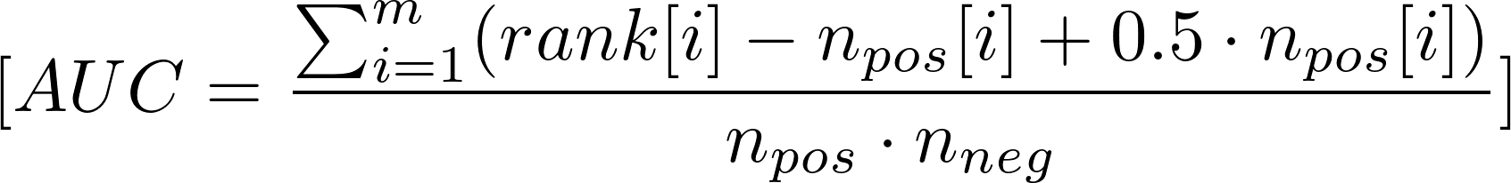
In the equations:
- "m" represents the total number of samples,
- "($rank[i]$)" denotes the ranking of the $i^{th}$ sample (ranging from 1 to m),
- $n_{pos}[i]$ refers to the number of positive examples before the $i^{th}$ sample,
- $n_{pos}$ represents the total number of positive examples,
- $n_{neg}$ represents the total number of negative examples.

Parts of the analyzing contents of results in Section IV are listed as follows:
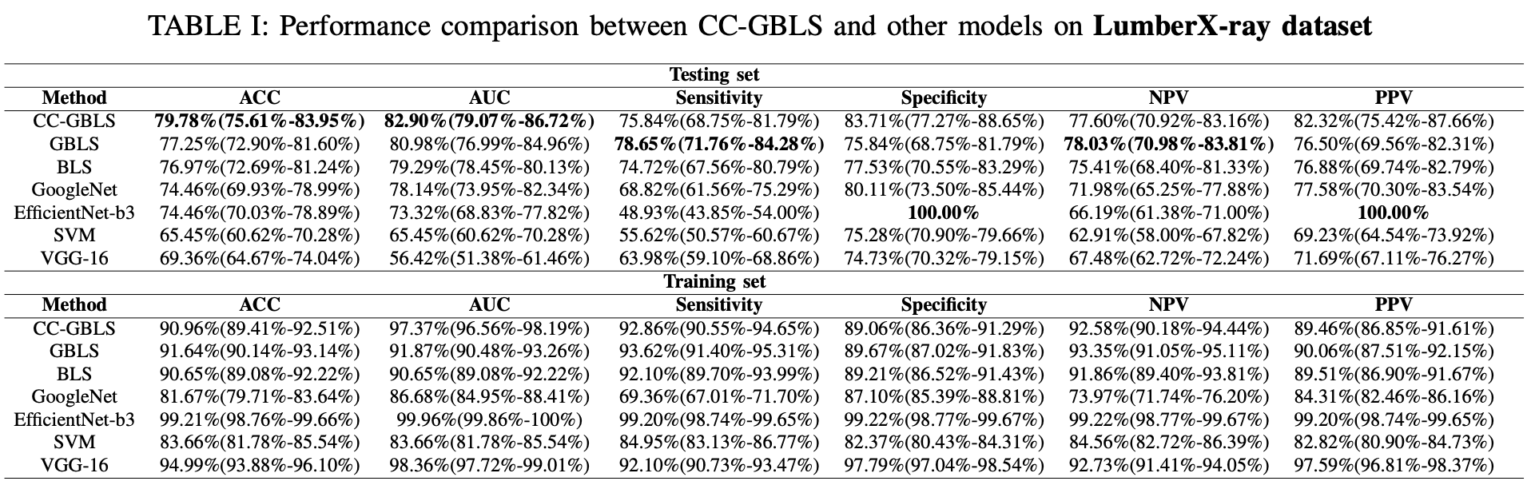
“According to TABLE I, our proposed model outperformed other models in terms of accuracy (3.94\% advantage), AUC (1.92\%), and PPV (4.74\%)”
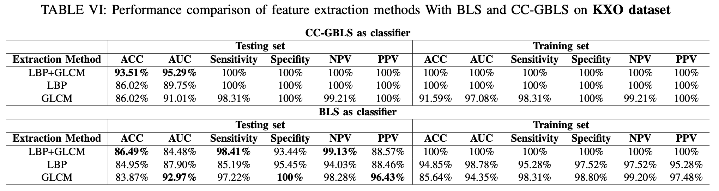 “....Besides, as shown in TABLE VI when using CC-GBLS as the classifier, the proposed model also obtains the highest AUC(95.29%).”
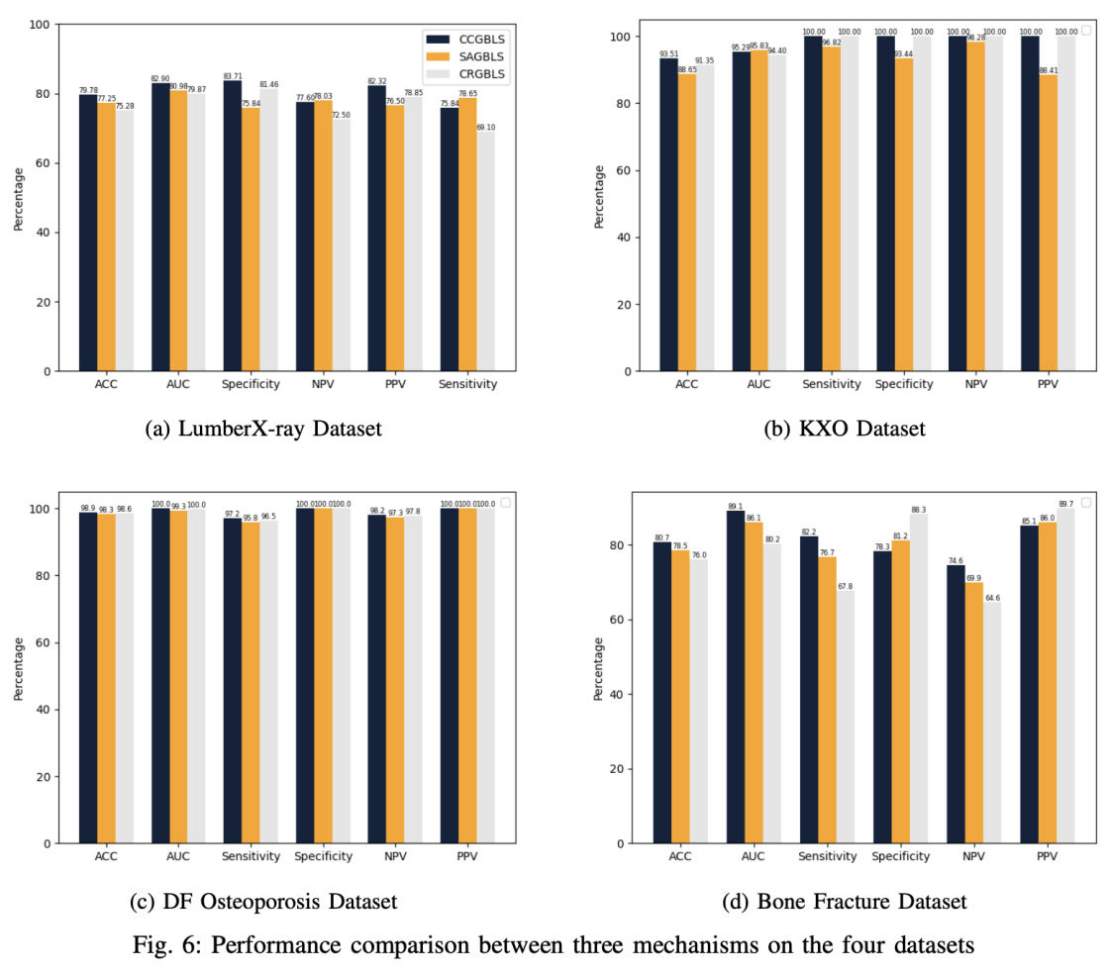
“...As shown in Fig. 6, CC-GBLS can achieve a 2.53% improvement in accuracy, 1.92% in AUC, 7.87% improvement in Specificity...”

(6) The values of parameters could be a complicated problem itself, how the authors give the values of parameters.
Author response: Thanks for your valuable comments. In this manuscript, we test the performance of several models on four datasets, including deep learning models and broad neural networks. The methods to give the values of parameters to each kind of models are listed as follows:
1) Deep learning models: In the training process, we select the appropriate value in [10⁻⁴,...,10^{-i},... 10⁻¹] as the learning rate α, and select the appropriate value in [8,16,...,2^{i},...,64] as the value of batchsize(the hyperparameter). At the same time, we use SGD as the optimizer in all model training processes and set the epoch of model training to 50.
2) Broad neural networks: For all models, we perform a grid search over the same range of parameters to pick the parameters that optimize each model. For the LumberX-ray, KXO, Bone Fracture datasets, the selecting interval for the number of mapping node groups(n1) is 10-30, for the number of nodes in one group(n2) is 10-50 and for the number of enhanced node groups(m) is 100-300. For the Deep Feature dataset, the selecting interval for the number of mapping node groups(n1) is 10-20, for the number of the number of nodes in one group(n2) is 10-20 and for the number of enhance node groups(m) is 10-50 Other hyperparameters are set as follows:
The parameter settings of the CCGBLS model on each dataset are shown as follows:
 | CC-GBLS |  |  | GBLS |  |  | BLS
 | n1 | n2 | m | n1 | n2 | m | n1 | n2 | m
LumberX-ray | 11 | 22 | 191 | 10 | 14 | 292 | 16 | 15 | 265
KXO | 18 | 43 | 197 | 10 | 44 | 100 | 13 | 48 | 100
Deep Feature | 11 | 22 | 19 | 15 | 14 | 20 | 12 | 15 | 11
Bone Fracture | 10 | 20 | 170 | 10 | 20 | 159 | 10 | 20 | 123

(7)The article can be further enhanced by connecting the undergoing work with some existing literatures. For example, https://doi.org/10.1109/TSMC.2020.3030792 ;https://doi.org/10.1016/j.ins.2022.08.115; https://doi.org/10.1016/j.eswa.2022.118834; http://dx.doi.org/10.1109/TCSS.2022.3152091 and so on.
Author response: Thanks for your valuable comments. According to the comments, we give a discussion about machine learning techniques in Section I, including optimization algorithms and their application. Besides, we already repolished this part to make it more continuous and added some related references, including the four articles mentioned above.

The related contents are listed as follows:
“Recently, machine learning technology, like optimization algorithms, has begun to receive wide attention from various industries. Wu Deng et al. introduced an enhanced MSIQDE algorithm based on mixing multiple strategies(EMMSIQUE) to improve the searching ability and descent ability [1]. A multistrategy particle swarm and ant colony hybrid optimization algorithm(MPSACO) is proposed to solve the airport runway planning problem and avoid taxiway conflicts and conflict propagation [2]. Furthermore, Yingjie Song designed an adaptive cooperative coevolutionary differential evolution with the dynamic hybrid mechanism of the quantum evolutionary algorithm and genetic algorithm(QGDECC) and employed it to propose a railway train delay scheduling method for effectively eliminating the impact of train delay [3]. Utilizing machine learning algorithms like principal component analysis (PCA), k - nearest neighbor (KNN), and support vector machine (SVM), a diagnosis method of NSD based on cognitive behaviour of emotional conflict is proposed to improve the diagnosis accuracy of non-severe depression (NSD) [4].”

- Wu Deng, Junjie Xu, Xiao-Zhi Gao, and Huimin Zhao. An enhanced msiqde algorithm with novel multiple strategies for global optimization problems. IEEE Transactions on Systems, Man, and Cybernetics: Systems, 52(3):1578–1587, 2022.
- Wu Deng, Lirong Zhang, Xiangbing Zhou, Yongquan Zhou, Yuzhu Sun, Weihong Zhu, Huayue Chen, Wuquan Deng, Huiling Chen, and Huimin Zhao. Multi-strategy particle swarm and ant colony hybrid optimization for airport taxiway planning problem. Information Sciences, 612:576– 593, 2022.
[3] Yingjie Song, Xing Cai, Xiangbing Zhou, Bin Zhang, Huiling Chen, Yuangang Li, Wuquan Deng, and Wu Deng. Dynamic hybrid mechanism-based differential evolution algorithm and its application. Expert Systems with Applications, 213:118834, 2023.
[4] Mi Li, Jinyu Zhang, Jie Song, Zijian Li, and Shengfu Lu. A clinicaloriented non-severe depression diagnosis method based on cognitive behavior of emotional conflict. IEEE Transactions on Computational Social Systems, 10(1):131–141, 2023.

(8) There are some grammatical errors seen in the paper. Check carefully for a few clerical errors and formatting issues.
Author response: Thanks for your valuable comments. We have checked carefully the whole manuscript and revised some grammatical errors and formatting issues.

Referee: 4
Comments to the Author
This paper addresses the representation learning problem of osteoporosis diagnosis using CT scan images. Specifically, the author proposes a broad neural network that combines collaborative-competitive representation learning and graph regularization to enhance the feature extraction and classification abilities. The paper conducts extensive experiments on two datasets and shows that the proposed model outperforms six baselines in terms of accuracy and efficiency.
Strengths:
1. The paper proposes an effective model for osteoporosis diagnosis that integrates CCRAE and graph regularization into BLS.
2. The paper uses two types of texture features to enrich the input of the model and capture more information from the images.
Weaknesses:
1. The paper does not provide enough motivation for using CCRAE and graph regularization in BLS. It is not clear how these techniques are related to previous works on BLS or osteoporosis diagnosis.
Author response: Thanks for your valuable comments. According to the comments, we further summarize the previous works and provide more content explaining the motivation for using CCRAE and graph regularization in BLS. We have already revised the corresponding contents in Section I to make the relationship between our proposed techniques and previous works on BLS or osteoporosis diagnosis clearer.

The related contents in this manuscript are listed as follows:
“These days, regularization techniques and manifold learning have been widely applied to the automatic diagnosis of osteoporosis and bone measurement. The least absolute shrinkage and selection operator regularization (LASSO) model [17] was applied to generate a risk assessment tool for identifying osteoporosis, which is clinically proven to work. Combined with manifold regularization, including local structurepreserved manifold regularization (LSPMR) and adaptive local shape-constrained manifold regularization (ALSCMR), a novel cascade amplifier regression network (CARN) is proposed for automated quantitative measurement of the spine [18]. To present texture analysis characterization techniques for the effective diagnosis of osteoporosis, a novel regularization dimension method is proposed [19], which uses a series of local fractal dimensions instead of a single global fractal dimension to characterize local texture variations. Considering the local invariance of the data, Junwei Jin et al. proposed discriminative graph regularized broad learning system (GBLS) [20] that incorporates manifold learning into traditional BLS and achieves better performance. They utilized the graph regularization algorithm to make the proposed model learn the intrinsic relationship between input data. Motivated by the effectiveness of regularization and manifold learning, we proposed an automatic diagnosis method based on graph regularized broad learning system to solve the limited learning ability of traditional BLS. However, insufficient data representation and mapping capabilities often limit the penalizing effect of regularization techniques on model performance.
Collaborative-competitive representation(CCR) has recently become a hot topic. Many variants of CCR have been designed for many classification tasks with good classification performance. Haoliang Yuan et al. [21] first proposed a collaborative-competitive representationbased classifier (CCRC) model incorporating a regularization constraint term into the objective function of CRC. CCRC considers the inter-class pattern discrimination among the classspecific representations. Zi-Qi Li et al. [22] proposed sparse and collaborative-competitive representation-based classification (SCCRC), which fuses sparse representation and collaborative-competitive representation for image classification. Jianping Gou et al. [23] proposed weighted discriminative collaborative-competitive representation (WDCCR) to achieve robust image classification, which designs the discriminative and competitive collaborative representation among all the classes by fully considering the class information. Inspired by the efficiency of the CCR algorithm, we designed a novel model named collaborative-competitive representationbased graph regularized broad learning system(CCGBLS) for automatic diagnosis of osteoporosis, which incorporates the collaborative-competitive representation mechanism into GBLS. The proposed model improved the feature representation capability and enhanced the graph regularization of traditional broad neural networks. Moreover, we devise an effective feature extraction method to assist the model in learning more information.”
2. The paper does not provide any ablation studies or analysis to show the contribution of each component of the proposed model, such as CCRAE, graph regularization, LBP-uniform and GLCM features.
Author response: Thanks for your valuable comments. We already added a new part titled “Ablation study of CCRAE mechanism, graph regularization and GLCM+LBP extraction modules” in Part B, Section IV, to show the contribution of different components. Through TABLE VIII, we present the result and analysis in this part.

The related contents in this manuscript are listed as follows:

We conducted ablation experiments on the LumberX-ray and KXO datasets to evaluate the effectiveness of each module. Table VIII contains the results of these experiments. By adding the LBP+GLCM feature extraction module, there is a significant improvement in model performance. The KXO dataset sees an impressive 20% increase in average ACC and a 10% increase in AUC. Incorporating the CCRAE mechanism and graph regularization into the BLS model also enhances performance on two datasets. With LBP and GLCM features, the model achieves substantial improvements on the LumberX-ray dataset. This includes a 1.97% increase in ACC, a 0.59% increase in AUC, a 3.97% increase in Specificity, and a 3.37% increase in PPV. On the KXO dataset, the model shows a 4.32% increase in ACC. Even without LBP and GLCM features, the model still achieves significant improvements on the KXO dataset. This includes a 14.29% increase in Sensitivity, a 10.21% increase in Specificity, a 7.31% increase in NPV, and a 9.37% increase in PPV. On the LumberX-ray dataset, the model achieves a 1.61% increase in ACC, a 2.00% increase in AUC, a 3.23% increase in Specificity, a 0.78% increase in NPV, and a 2.76% increase in PPV

3. The related work section is not comprehensive enough. The authors are encouraged to provide a more in-depth discussion on graph learning. The author could do a better job by citing some relevant papers [1-3] and provide a better discussion of this topic.
Author response: Thanks for your valuable comments. In part “C.Graph learning and GBLS”, Section II, we give an in-depth discussion on graph learning. Besides, we repolish the whole part to make it more continuous. Moreover, we have added all recommended papers listed below.

The related contents in this manuscript are listed as follows：
“With the continuous penetration of artificial intelligence technologies, graph learning has gained attention from many researchers, which proves effective for many tasks, such as classification, link prediction, and matching. Generally, graph learning methods extract relevant features of graphs by taking advantage of machine learning algorithms [30]. Based on this, many graph learning algorithms have been proposed. Through constructing a sparse similarity graph named L2-graph based on the IPD property of ι2-norm-based projection space, Xi Peng et al. [31] proposed the robust subspace clustering and subspace learning algorithms. Mouxing Yang et al. [32] proposed robust multi-view clusteRing with incomplete information (SURE) to solve Partially View-unaligned Problem (PVP) and Partially Sample-missing Problem (PSP) under a unified framework. And Yijie Lin et al. [33] proposed a novel method termed Contrastive Matching with Momentum Distillation which could better explore the node-to-node and edge-to-edge correlations and adaptively penalize the noisy assignments, thus leading to the edge-level noisy correspondence(ENC). Combing graph learning with BLS, graph regularized broad learning system(GBLS) takes into account the intrinsic relationships of data during training through constructing the intrinsic graph. In GBLS model, a graph regularization term extracted from the intrinsic graph is added to the standard BLS model and the process of constructing the regular term of the graph is shown as follows.”

[31] Constructing the L2-Graph for Robust Subspace Learning and Subspace Clustering
[32] Robust Multi-view Clustering with Incomplete Information
[33] Graph Matching with Bi-level Noisy Correspondence

4. More datasets for osteoporosis diagnosis are encouraged, such as Osteoarthritis Initiative (OAI) dataset or Osteoporotic Fractures in Men (MrOS) dataset.
Author response: Thanks for your valuable comments. The Osteoarthritis Initiative (OAI) dataset is for the investigation and research of knee osteoarthritis. However, this manuscript is mainly aimed at the automated diagnosis of osteoporosis. Simultaneously, most Osteoarthritis Initiative(OAI) datasets are unlabeled while this paper focuses on supervised classification tasks. So the dataset may not be suitable for this paper. Due to permission restrictions, we are temporarily unable to obtain Osteoporotic Fractures in Men (MrOS) dataset. Details of the access restriction information can be found at the link below:
https://dbgap.ncbi.nlm.nih.gov/aa/wga.cgi?page=login.
However, after conducting extensive surveys to the best of our abilities, we select two effective datasets and carry out several experiments on them. Through experiments from multiple perspectives, our proposed model is proven to have advantages over CNN models and traditional broad neural networks. We add the introduction of two new datasets in part titled “A. Dataset and Experiment Setting” in Section IV. Moreover, we add more content to analyze the experimental results on these two datasets from part (1) to part (6) in Part “B. Results Analysis”, Section IV

The related contents in “A. Dataset and Experiment Setting” part in Section IV：
“Deep features of hip radiographs datasets(Deep Feature Osteoporosis dataset): This dataset consists of 898 subjects, including 519 subjects with osteoprosis and 379 subjects with no findings. This dataset is divided into the training set and testing set with the ratio of 6:4. The dataset link is as follows: https://data.mendeley.com/datasets/gmg3vvmvj4/1
Bone fracture of several joints dataset(Bone Fracture dataset): This dataset consists of 9463 images, dividing into training set with 8863 images and validation set with 600 images. More information of this dataset can be accessed thorugh https://www.kaggle.com/datasets/vuppalaadithyasairam/bone-fracture-detection-using-xrays.”

Parts of the results analysis on the two datasets in “B. Results Analysis”, Section IV are listed as follows:
“For the Deep Feature Osteoporosis dataset, we compare it with GBLS, BLS and two traditional mechine learning models, Decision tree(DT) and Artificial neural network(ANN), which have been applied to automatic diagnosis of osteoporosis. The results are shown in Table III. CCGBLS achieves relatively better performance. It obtains the best accuracy(98.89%),
Specificity(100%), PPV(100%). ANN achieves the highest AUC(99.99%).
For the Bone Fracture dataset, we compare three broad neural networks with three classic CNN models. The results are shown in Table IV. CC-GBLS achieves the best accuracy(80.67%), AUC(89.11%), Sensitivity(88.22%).”

We already added the complete analysis of the experimental results on these two datasets and marked all added contents blue in the part “B. Results analysis”, Section IV.

